Topic | LearningOutcomes | Innovative/Art Integration/ExperientialLearning/Interdisciplinary
Real Numbers | After studying this lesson, students will be able to explain and solve the problems related to the  Fundamental theorem of Arithmetic and finding LCM and HCF. They will be able to explain the differences between rational and irrational no's. They will be practising transposing. | Complete family of number system  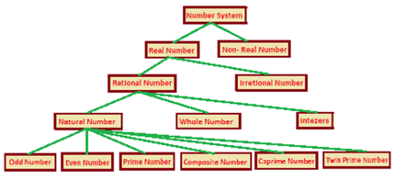
  Art Integration:Draw number system
Polynomials | Students will be able  To tell the number of zeros for a given polynomial.  To verify the relationship between the zeros and coefficients.  To understand the geometrical meaning of zeros and reading it from graph. | Represent geometrically the quadratic polynomial. From graph find the number of zeros hence factors.  Experiential Learning…To draw the graph of given polynomial.
Linear equations in two variables | Students will attain  If two unknown quantities are to be evaluated than we necessarily need to have two conditions related to them.  They can formulate the pair of equations and solve them using elimination or substitution method. | Project on income and expenses:  Income and Expenses: The income of a person can be expressed as a linear equation in two variables where one variable represents the number of hours worked and the other variable represents the hourly wage. For example, if a person earns Rs. 100 per hour and works for x hours, then their income can be represented by the equation y = 100x. Similarly, the expenses of a person can be expressed as a linear equation in two variables where one variable represents the fixed expenses and the other variable represents the variable expenses. For example, if a person has fixed expenses of Rs. 5000 per month and variable expenses of Rs. 1000 per day, then their expenses can be represented by the equation y = 5000 + 1000x.
Quadratic equations | After studying this lesson students should know  - All formulas and all important concepts related to the quadratic equations.  - Students should know the nature of solutions by using Discriminant.  - Students should know the factor method, method of completing the squares, and quadratic formula for solving the Q.E.  - Students should also know the method of implementation of these formulas in simple and complex problems. | Experiential learning: Students will be taken to school fountain in school garden.They will note various dimensions and than various questions will be asked.
Arithmetic progression | After studying this lesson students should know  - Sequence, Series and Arithmetic Progression.  - All formulas and all important concepts related to the Arithmetic progression.  - Students should be able to find the nth term of the AP from the starting and from the end of the sequences.  - Students should also be able to find the sum to n terms of the AP from the starting and from the end of the sequences. | Art integration: To verify that the given sequence is an arithmetic progression by paper cutting and pasting method.
Similar triangles | After studying this lesson students should learn the  - Difference between similarity and congruency of plane figures.  - Different similarity and congruency conditions.  - Statement and proofs of B.P.T. Ratio of area of two similar triangles, Pythagoras theorem and the converse of Pythagoras theorem.  - Students should learn the implementation of these theorems in the different problems. | Experiential learning : A group of students will be asked to collect different examples of similar objects and other will be asked to collect different examples of congruent objects. A classroom discussion will be held.

Coordinate Geometry | After studying this lesson students should  - Learn the formulas of finding the distance between two points,  - Able to understand section formula and mid-point formula,  - Understand the formula of finding the area of triangle, quadrilateral and the centroid of the triangle.  - Know the implementation of all these formulas in different problems.
Surface area and volume | After studying this lesson students should know  - Different shapes of solid figures.  - All formulas and all important concepts related to the surface area of solid figures.  - All formulas and all important concepts related to the volume of solid figures.  - Solving the problems related to the solid figures.  - Students should also know the method of implementation of these formulas in simple and complex problems. | Surface Areas and Volumes: Clay Activity  In this activity, students will calculate the surface areas and the volumes of the combination of solids.  In this activity, students with the help of clay make some solid figures and will calculate the change, if any, in the surface area and the volume of a solid when it is converted into different solid or multiple solids, either of the same or different shapes.  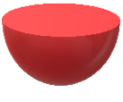  Explanation of the Activity  Divide the class into two groups. Bring some modeling clay to the classroom. Ask a group to shape the clay in any of the basic solids, such as cube, cuboid, cylinder and sphere. They need to take the required measurements and calculate the surface area and the volume of the solid that they have made. Now, the other group should break the solid and make numerous smaller solids from the clay. Then, they need to take the required measurements and calculate the surface area and the volume of the smaller shapes. Thereafter, ask both groups to analysis the relation between the surface area and the volume of the original solid and the new solids. Conduct a similar activity to prove that when the shape of a solid object is changed, its surface area changes but the volume remains constant. For this activity, change the original basic solid into the basic solid of a different shape.  
Probability | After studying this lesson students should know the  - Probability of sure event impossible event equally likely events.  - Range of Probability.  - Method of writing sample space when different number of coins are tossed.  - Method of writing sample space when different number of dice are thrown.  - Students should know the terms associated with the playing cards and become able to tackle the problems with them.  - Able to find probability in different situations. | Art integration :  Explain the terms associated with the playing cards i.e. possible outcomes, number of black(52) and red(52) cards, number ace(4) and face(12) cards etc and their probabilities.  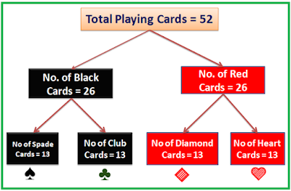
Statistics | - After studying this lesson students should know  - All formulas of finding mean of the given data.  - All formulas of finding mode of the given data.  - All formulas of finding median of the given data.  - Method of finding the less than ogive and more than ogive and the median from the graph.  - The relation between mean, mode median (Empirical formula)  - Students should also know the method of implementation of these formulas in simple and complex problems. | Experiential Learning :  Students will be asked to collect data from their locality and study mean mode and median of the collected data and find the relationship among three.
Introduction toTrigonometry | After studying this lesson students should know  - All six types of trigonometric functions.  - Relationships between trigonometric functions, angles and sides.  - Values of trigonometric functions with standard angles.  - Transformations of trigonometric functions.  - Trigonometric Identities and their Implementations.  - Method of solving the problems with the help of trigonometry. | Experiential Learning : Students will be taken outside the classroom and will ask to find out the height of the wall of the school building using Clinometer. They will be asked to find out the angle of elevation of sun at that movement.
Tangents to the circles | - After studying this lesson students should know  - the circle and the different terms associated with the circle.  - Tangent and secant to the circle.  - Tangent is always perpendicular to the radius of the circle.  - Length of tangents from external point to the circle is always equal.  - Students should be able to apply all the results and concepts of circle in the daily life problems problems. | Art integration: By using paper cutting and pasting theorem will be proved.  Prove that lengths of tangents drawn from an external point of a circle are equal  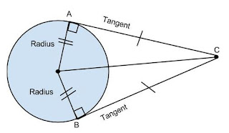
Area related to circle | After studying this lesson students should know  - The circle and its components.  - The area and perimeter related to all the plane figures like circle, semi-circle, quadrant, segment, sector, different types of triangles and different types of quadrilaterals.  - Method of solving the problems of plane figures in combination form | Chart making: Teacher will ask students to prepare chart for the following formulas using art and craft. They will be drawing required figures also.  Area of circle  Area of minor sector  Area of major sector =  Area of minor segment =  Area of major segment =  Area of Quadrant =  Area of Quadrant =

