Class-X (English)
Term-I

Theme/ Topic | Expected Learning Outcomes | Innovative/Art Integration/Experimental Learning/Inter Discipline
FIRST FLIGHT-  Unit 1  Chapter-1 A LETTER  TO GOD | Students will be able to:  - To understand the plot and character of the story.  -To enjoy and appreciate  the story and the use of  language.  -To puzzle out the meaning of some  unfamiliar words in the story.  -To become aware of the theme and emotions.  -To understand the importance of faith  -To believe that faith can move mountains  -To develop such a faith in them that boosts their  confidence in them.  -To encourage them to  develop faith in themselves.  -To lend a helping hand to | To enable the students:  -To develop their basic  skills of language - listening, speaking,  reading and writing.  -To understand the plot  and character of the story.  -To enjoy and appreciate  the story and the use of language.  -To puzzle out the meaning of some  unfamiliar words in the story.  -To become aware of the theme and emotions.  -To understand the importance of faith  -To lend a helping hand to the needy.
Nelson Mandela | Students will be able to:  -Understand the  consequences of  discrimination and how to  rise above prejudices  -become the change  makers  -instil a feeling of  patriotism and work for  the betterment of society  by contributing towards  achieving humanitarian  goals  -revise usage of article  ‗the‘ before proper nouns  -read, write, speak and  understand English  correctly.  -Strengthen usage of  correct grammar while  expressing orally and in  writing.  - enrich vocabulary and  use the same correctly. | To enable the students  to-  -understand that  discrimination is injustice  -understand the  importance of humanity  -understand how peace  can prevail  -get an insight into the  long struggle for  democracy and Mandela‘s  belief about humanity  - give a feeling of unity  and a longing for change.  -join together in making  changes for a better future  -bring up the sense of  pride for one‘s nation and  a sense of obligation to  continue doing the right  thing  -learn usage of ‗the‘  before proper noun  (definite article)  -learn about verb-noun  pairs and homophones  -enrich with idiomatic  expressions  -learn new vocabulary like  besieged by, chevron,  despised, emancipation,  resilience etc.
Dust of Snow | To enable the students to –*Appreciate the theme and message conveyed. *Understand phrases and catchy lines from the poem.  *Develop their aesthetic sense.  .*Understand the idea that nature is a perennial source of joy. | Students will learn the values of–  *Adopting an optimistic attitude towards life.  *Realize that seemingly insignificant events can bring about significant change in our lives.  * They would be able to understand the theme of glorifying nature and its beauty.  *They would be able to understand that nothing in nature is inauspicious.  .  *Art in the form of History ( Superstitions in our society) , Geography( Global warming) will be integrated.  *Reading of the poem by the students and explanation by the teacher would be taken up.  *Theme and summary of the poem would be discussed.
Poem-FIRE AND ICE | Students will be able to:  -To read, write, speak understand English correctly.  -To enrich the vocabulary  to use the same correctly.  -To understand the  difficult words and phrases  in the poem.  -To appreciate the beauty,  rhyme and style of the  poem.  -To understand the thought  and imagination contained in the poem.  -To think about different human emotions and their  effect.  -To write their feelings in the form of short poems.  -To move from factual  understanding to critical  thinking.  -To understand and  identify the figures of  speech. | Students will learn the values of -  -Importance of Love  -Imagination  -Faith  -Control of emotions  -Patience  -Avoid instant reactions  Art in the form of Psychology, Sociology, Languages and Science will be integrated.
A Triumph of Surgery | The students will be able to -  -develop their imaginative and analytical skills.  -gain knowledge of different kinds of pet animals.  -understand that dog is the most faithful pet.  -understand that declined health was the outcome of Mrs Pumphrey‘s over- caring nature.  -understand the pompous nature of the rich. | Students will learn the values of-  Love, care and concern for the animals.  Art in the form of Psychology, Sociology, Languages and Science will be integrated.
The Thief’s Story | Students will be able  -To enrich their vocabulary.  -To read the lesson in proper intonation.  -To understand importance of education.  -To understand the two different characters i.e. Anil & Hari Singh  -To get enjoyment through reading the lesson.  -To appreciate/comprehend the text.  -To express themselves in grammatically correct language.  -To comprehend the text  locally and globally.  -To learn vocabulary and its usage within appropriate context.  -To develop confidence in speaking skills. | To enable the students  to imbibe values like faith, confidence, importance of education and forgiveness  2.Art in the form of psychology and sociology will be infused  3.Speaking Skills (ACTIVITY)  .#Imagine the circumstances that can turn a fifteen year old boy into a thief.  #How can education change a man’s perspective towards life?
Two Stories about Flying | Students will be able to:  To enable the students-  -To inculcate the moral values  -To enhance the vocabulary -To enable the learners to extrapolate from the given text  -To enable the students to share their personal experiences  -To enhance their LSRW skills  -To make them understand that to succeed one has to put in hard work  - To make them understand that continuous practice makes a man perfect  - To teach them that one has to try regardless of a possibility of a failure | - Students will learn the values of-  -Courage  - Determination  - Kindness  -Acceptance  -Accept challenges  - Courage to face reality  - Art in the form of Psychology, Sociology, Language and Geography will be integrated.
From the Diary of Anne Frank | Students will be able  - To understand the characters and their role in the novel  -To understand elements of humour in the novel  -To understand the plot and the theme of the novel  -To critically think about identity  -To empathize and relate to Anne Frank  -To understand the importance of teacher  -To understand child psychology  -To understand student teacher relationship  -To learn to accept of situations and face them with a lot of courage and find solutions to problems in life | 1.The students will learn  *values like being kind,hopeful and never to give up spirit.  *that one should invest in memories,not in material things.  2.Art in the form of language skills,history and child psychology will be integrated.  3.Group activity—-  *Quiz based on World War II and Hitler will be organised in the class.  *JOURNAL BUDDIES  Students will select one topic out of the topics provided by the teacher.The students will be asked to write a diary entry on any one topic.Then it will be discussed in the class.
A Tiger in the Zoo | BY THE END OF THE  LESSON, STUDENT SHALL BE ABLE TO:  Understand the  importance of  freedom.  Understand the  dangers of  deforestation and blessings of  forestation.  Understand that all animals will be  happy only in their natural habitat.  Understand the  responsibility of  present generation in preserving the environment and  earth.  Recite poem with proper intonation and rhythm. | Students will be able :  -To understand the  dangers of deforestation  and blessings of  forestation.  -To understand that all  animals will be happy only  in their natural habitat.  -To understand the  responsibility of present  generation in preserving  the environment and earth.  -To enable the students to  learn to recite poem with  proper intonation and  rhythm.  -To stir their thinking.  To use new words and  phrases of English.  -To make them realize the  importance of animals.
The Midnight Visitor | The students will be able to -  -develop their imaginative and analytical skills.  -understand thatsecret  agents in fiction are projected like ideal men.  -understand that life is full of unexpected twists and turns.  -analyse the importance of presence of mind and face the situation rather than running  away.  -develop the ability to think quickly, act calmly and wisely in a situation of danger or surprise | To enable the students-  -use the key words, phrases, expressions, and grammar correctly and appropriately.  -know more about the author, detective stories and related information about secret agents.  - think quickly, act wisely and calmly in the situation of danger and surprise.  -make character analysis of Ausable, Max and Fowler  -analyse Ausable‘s ability to think quickly and calmly in a situation of panic.
A Question of Trust | To enable the students to -  * Analyze the theme that “Crime never pays” and moral value that no crime is justifiable will be imparted from the text.  * Summarize the chapter  *Analyze the characters.  *Answer questions and articulate their point of view regarding honesty being the best policy. | Students will learn the values of –  *Being honest in their life.  * Realize that the price of committing any crime will be ruthless.  * Art in the form of Psychology (Into the minds of criminals ) will be integrated.  *Reading of the lesson by the students and explanation of the difficult expressions by the teacher would be taken up.  *Theme of the chapter would be discussed.
Glimpses of India | The students will be able to –  -know the expressions used in the lesson and their usage.  -appreciate the old methods of baking bread in Goa.  -respect traditions.  -respect values, beliefs and customs of others  -develop their imaginative and analytical skills. | PEDAGOGICAL STRATEGIES  The students will gain knowledge about traditional Goan village in Goa, coffee Coorg and Assam famous for tea gardens. They also collect information on how bakers bake bread now and how the process has changed over time. By studying the maps the pupils find various routes to reach Coorg, the smallest district of Karnataka. Students also gain knowledge about the history of tea and how and when it became popular in India.  GROUP ACTIVITIES AND HANDS ON LEARING  Students will be asked to find a travel brochure about a place they have visited and adding details from their own experience will write an account to give the reader a picture of the place. The students will also be asked to collect information about tea, e.g. its evolution as a drink, it’s beneficial qualities. They would be suggested to consult an Encyclopedia or visit internet websites. Then they would form groups of five and play the following roles: Imagine a meeting of a tea planter, a sales agent, a tea lover(consumer, a physician and a tea-shop owner. Each person in the group has to put forward his views about tea.
How to Tell Wild Animals | To enable the  students-  -identify some of the wild  animals with their peculiarities  -enjoy and appreciate  humorous poems  -understand meaning of  expressions like  crocodile  tears, bears hug,  hyenas  smile etc and  -recall similar  expressions  and popular ideas  about  wild animals in their own  language(s)  -understand poetic license.  -Form mental pictures(imagery)  - Admire bounty of nature.  - Explore language and learn new vocabulary like nonplus, caress, etc. | Students will be  able to:  -understand the  identifying  features of few  animals  -appreciate a  different  genre (humour)  -enjoy reading the  poem  for pleasure  -enrich vocabulary  and  use the same  correctly.  -respect diversity  -get well versed  with  imagery and  rhyme scheme.
The Ball Poem | 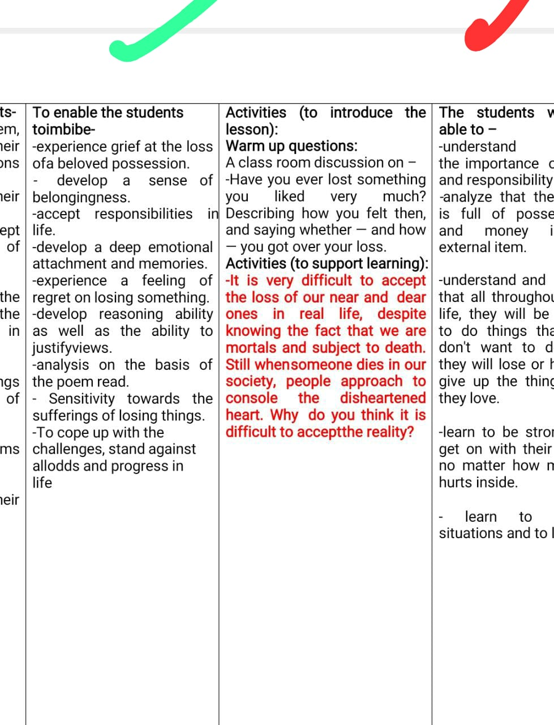
Footprints Without Feet | To improve vocabulary  -To enjoy and appreciate the science fiction  -To know the effects of misusing the technology -To develop the four skills of the language.  -To develop positive attitude towards the language.  -To enable them to discriminate the good from the evil.  -To develop moral values in the students.  -To understand that Science is a boon for humanity and is a good servant if correctly used - To understand elements of horror, suspense, conflict in the chapter | The students will be able to  - understand that an individual is powerless compared to larger society  - know that the ambition can be the greatest foe of man  - know the effects of misusing technology  - understand that Science is a good servant but a bad master  - improve vocabulary by reading the chapter  develop flair for language .
Amanda | the learner's context and experiences  -To learn the use of imperatives  -To enable the students understand and enjoy the theme and language by reading Amanda.  -To enable the students to be specific in reflection, expression and individual opinion and deeper understanding of Amanda.  -To enable the students identify the connection to words or phrases that resonate with other things.  -To enable the students know more about the poet or background of the poem.  -To enable the students enrich their vocabulary.  -To enable the students acquire a few grammar items, stress patterns, punctuation, pronunciation, rhyme and rhythm | Activity (To introduce the poem):  Do you know the story of Rapunzel? Do you wish to be like her? Why?  Activity/Assignment:  Every child feels that she/he is controlled and instructed not to do one thing or another. You too may feel that your freedom is curtailed. Write down some of the things you want to do, but your parents/ elders do not allow you to. How do you react when your freedom is curtailed?  -To introduce imperatives and their conversion in narration, the teacher can give few imperative sentences in class, in direct speech, then ask the students to change them along with discussion of the rules.
Term-2
Mijbil the Otter | The students will be able to –  Describe a repeated action in past  - learn about noun modifiers  -learn about phrases that indicate a particular quantity of something that is not usually countable.  - read and identify the main points of the text.  - use new words and their meanings.  - comprehend the chapter  -Empathize with animals  - Learn to take care about animals  -Learn to be responsible towards other life forms | To enable the students-  -Describe a repeated action in past  -learn about noun modifiers  - learn about phrases that indicate a particular quantity of something that is not usually countable  - read and identify the main points of the text.  -use new words and their meanings
Madam rides the Bus | To enable the students to –*Appreciate the theme and message conveyed. *Understand phrases and catchy lines from the story.  *write the character sketches.  .*Understand the idea that life and death are integral to each other. | Students will learn the values of–  *Adopting a curious attitude towards life.  *Realize that life brings joy and death makes us sad.  * They would be able to realize that life never comes to a standstill.  *Develop keen observational skills.  .  *Art in the form of Psychology will be integrated.  *Reading of the text by the students and explanation by the teacher would be taken up.  *Theme and summary of the text would be discussed.
The Making of a Scientist | To enable the students-  -develop interest in small  discoveries and inculcate  the habits thereof.  -learn about Richard  Ebright and his journey to become a scientist.  -understand what is  biography and the  biographical element of  Richard Ebright through  this lesson.  -understand that learners  can get knowledge of various stage, species and  growth of butterflies.  -analyse that the learners  can get ample knowledge  about the theory of cell.  -analyse that Richrad  Ebright was multi talented  and used to put extra effort  in his work  -evaluate that Ebrights‘  works were directly  related to Biology and  discovery of cell‘s  structure helped the  scientific community to  understand how the  organisms function and  grow. | To enable the students to  imbibe-  -inculcate competitive  spirit in them.  -develop their  curiosity to enhance  their knowledge,  learning, be observant  and unending hunger  to discover more.  -share their knowledge  with others.  -do real experiments to  test their findings and relate with real life situations.  -develop competitive spirit.  -develop their reading habit.  -develop a strong  desire to work really  hard on their area of interest.  Art in the form of Psychology, Sociology, History , Geography, Languages and Science will be integrated.
The Necklace | - To know that satisfaction is the key to happiness.  - To understand that we should be content with what life gives us .  - To understand and appreciate the stories giving lessons of life .  - To understand ‘Honesty is the best policy’.  - To understand that you may pay a terrible price for greed and desire.  - To express effectively ,share ideas and develop appropriate style of writing..  - To enrich vocabulary | - To know that satisfaction leads to contentment which is a key to happiness.  - To understand that acceptance of mistake will make the life easier ruining your inner peace .  - To be able to express ideas freely and acceptance of ideas.  - To understand that acceptance of mistake will make the life easier in contrast to hiding the truth.  - To enrich vocabulary like Incessantly, spitefully ,exquisite etc  - read with proper stress and intonation.  - To enable them to develop their writing and reading skills  .To express effectively ,share ideas and develop appropriate style of writing
The Sermon at Benares | The students will be able to –  -To enable them express themselves in grammatically correct language.  - To enable the learners extrapolate from the given text.  -To sensitise the students to the fact that death is the ultimate truth in the world.  -To enable them use new words and phrases in their own language.  -To help them know that nothing is permanent.  Everything is subject to decay. All human beings are mortals. And mortals are bound to die.  -They help them know the  fact that grieving on the death of a relative brings nothing. It only invites physical pain | 1.The students will learn and understand  *the importance of being righteous  *the importance of honesty and integrity in life  2.The students will analyse the fact that death is inevitable  3.Art in the form of history,moral values,drawing and language will be integrated.  4.Group activity—The students will be asked to prepare a flow chart on the life of Buddha
The Proposal | The students will be able to –  To help them differentiate between internal and external conflict.  -To help them identify the different types of conflict within the story.  -To help them articulate the necessity of conflict within the text.  -To appreciate/ comprehend the text.  -To express themselves in grammatically correct language.  -To make understand drama as the form of literature.  -To make them appreciate the efforts of different writers and their style.  -To make them aware of the Russian Wedding custom and culture  -To compare the wedding ceremonies of India and Russia | To enable the students- - To help them differentiate between internal and external conflict.  -To help them identify the different types of conflict within the story.  -To help them articulate the necessity of conflict within the text.  -To appreciate/ comprehend the text.  -To express themselves in grammatically correct language.  -To make understand drama as the form of literature.  -To make them appreciate the efforts of different writers and their style.  -To make them aware of the Russian Wedding custom and culture
Tree | - Read the poem with proper expressions, pauses and voice modulation.  - To be able to comprehend the poem  - To enhance the vocabulary and Identify the figures of speech.  - To appreciate the theme and  Style of writing of the poet  - Understand phrases and catchy lines from the play.  - To make develop thought critical analysis on the basis of text read.  - To make them understand mother nature is inevitable.  - To make them appreciate equality, empathy and understanding. | - To imbibe values like empathy. equalitetc.  - To enhance the vocabulary  - To compare the natural forests to the artificial ones that man has created inside the house to suit their purpose.  - To imagine tree as a symbol of mankind.  - To revise about various poetic devices like imagery, personification, simile , free verse etc..  - To do strengths’ and weakness’ study of their own personality .  - To comprehend the poem locally and globally.  - To infer the meaning of unfamiliar words and phrases.
FOG | The students will be able to –  -understand the powerful nature and worth of natural occurrences .  -revise different types of poem read earlier and know about Haiku  -appreciate poem and understand metaphor  -know how natural occurrences could be beautifully expressed in verses.  -understand change is unavoidable | understand that nature is more powerful than anything that humans can produce  -understand that change is an unavoidable and natural process  -appreciate imagery and metaphor used in poem and understand their relevance.  - analyse the poem through appropriate inferential questions  -enhance their vocabulary and comprehension of the poem  Language learning will be infused with Science and Environmental Science by understanding the natural phenomenon of fog and the science behind it.
BHOLI | The students will be able to –  --To sensitize the students to the importance of education.  -To explain the importance of emotional security and family support for children.  -To indicate the need of love, encouragement and education for the disabled to fight against their odds.  -To demonstrate the use of simple past and past perfect tense in speech and writing.  -To stuff moral values in the students such as dowry is a social abuse, any disabled should not be made fun of etc. | To enable the students to imbibe-  • Compassion  • Confidence• Care and concern for girls  • Empathy  • Gender equality  • Willingness to help others  • Nobility  -To sensitize the students to the importance of education.  -To explain the importance of emotiona security and family support for children.  -To indicate the need of love, encouragement and education for the disabled to fight against their odds.  -To demonstrate the use of simple past and past perfect tense in speech and writing.  -To stuff moral values in the students such as dowry is a social abuse, any disabled should not be made fun of etc.
The Tale of Custard Dragon | The students will be able to –  -To enable the students to comprehend the text.  -To enable them to verbally communicate.  -To enable them to enhance their writing skills.  -To enrich vocabulary and its usage within appropriate context.  -To enable them express themselves in grammatically correct language.  -To develop a love for literature in students.  -To introduce the students with life and works of Ogden Nash. | 1.The students will understand the simplicity of the animals and the greediness and complex nature of human beings.  2.Art in the form of psychology,languages ,creative art and music will be integrated.  3.Group activity—The class will be divided into groups of five each.Each group will be asked to frame a ballad on any topic/theme of their choice.Then each group will be asked to give their presentation
For Anne  Gregory | To enable the students  -To infer the contextual  meaning of the text.  -To enable the students to know their strengths and  weaknesses  -To infer the meaning of  unfamiliar words and  phrases.  -To identify the poetic  devices like metaphor,  alliteration etc.,  -To know about the rhyme  scheme used in the poem | Students will learn the values of-  ● Appreciation  ● Respect  ● Beauty of thought  ● Purity of Soul  ● Acceptance  ● Accept Challenges  ● Courage to face the reality  Art in the form of Psychology, Sociology, Languages and Music will be integrated.
The Book that Saved The Earth | To enable the students to -*Comprehend the chapter  and enhance their  vocabulary.  *Understand the theme  that nothing in this world is insignificant or unimportant.  *Understand that all knowledge cannot be used in every context. | Students will learn the values of –  *coexisting with every creature to save this universe from total destruction.  * using one’s knowledge appropriately and according to the need.  *Develop ability to interpret situations and act accordingly.  * understand that situations and circumstances make even a trifle object to be extremely valuable.  * Art in the form of Psychology,Geography will be integrated.  *Reading of the lesson by the students and explanation by the teacher would be taken up.  *Theme of the chapter would be discussed.

